OLYMPIC GAMES.

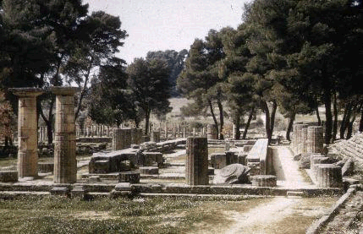

The temple of Hera in Olympia, Elis, Greece

in a great athletic festival in Elis, in western Greece once every four years, men from all over Greece came to compete (Women were not allowed to compete). This was called the Olympic games because the place was called Olympia. It was a religious festival to honor the Greek gods Zeus and Hera. We don't know when men first began celebrating the Olympic Games, but they
were certainly already doing it in the time of Homer, by 776 BC. And they were celebrated from then on, every four years without fail, until people converted to Christianity and the Roman Emperor Theodosius banned the games in 393 AD. That's more than a thousand years! The games were so regular that people used them to date by. They would say, I was born in the second year of the twenty-fourth Olympiad (starting from 776 BC). Can you figure out what year that would be in our reckoning?When it was time for the games, the rulers of Elis sent out messengers all over Greece and to the Greek colonies around the Black Sea and the Mediterranean. They declared a truce throughout the Greek world for a month. No matter who you had a war with, you had to stop the war and let their athletes and performers go through your city-state safely to get to the Olympic Games. Each city-state paid for a few athletes from their city to travel to Elis. But if you had ever been a slave, or if you had ever done anything against the gods, then you couldn't be in the Olympics. And, the men had to swear that they had already trained for at least ten months. This meant that only men who were pretty rich could be in the Games, so they could afford to take so long off work, and also pay a trainer.Olympic Games (ancient), most famous of the four great national festivals of the ancient Greeks, the other three being the Isthmian Games, the Pythian Games, and the Nemean Games (see Games, Ancient). The ancient Olympic Games were celebrated in the summer every four years in the sanctuary of the god Zeus at Olympia. The history of the games dates from 776 bc.
Early in the year of the Games, envoys were sent throughout the Greek world to invite the city-states to join in paying tribute to Zeus. The city-states then dispatched groups to vie with one another in the splendor of their equipment and the proficiency of their athletic feats. The competitions were open only to honorable men of Greek descent.The order of the events is not precisely known, but the first day of the festival was devoted to sacrifices. The second day began, in all probability, with footraces, for which the spectators gathered in the stadion, an oblong area enclosed by sloping banks of earth. On other days wrestling, boxing, and the pancratium, a combination of the two, were held. In the first of these sports the object was to throw the antagonist to the ground three times. Boxing became more and more brutal; at first the fighters wound straps of soft leather over their fingers as a means of deadening the blows, but in later times hard leather, sometimes weighted with metal, was used. In the pancratium, the most rigorous of the sports, the contest continued until one of the participants acknowledged defeat.Horse racing, in which each entrant owned his horse, was confined to the wealthy but was nevertheless a popular attraction. After the horse racing came the pentathlon, a series of five events: wrestling, discus throwing, javelin hurling, long jumping, and sprinting. The exact sequence of the sports and the method used to determine the winner are not known. The discus was a plate of bronze, probably lens shaped. The javelin was hurled with the aid of a strap wound about the shaft, producing a rotary motion for greater distance and accuracy. The jumping event was judged for distance, not for height. The closing event was a race run in armor.The victors were awarded crowns of wild olive. Celebrated by poets, they often lived for the rest of their lives at public expense.

Games of I Olympiad
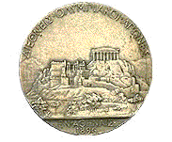
Athens 1896
Date: 6 April 1896

Date of closing: on April, 15 1896

Games of II Olympiad
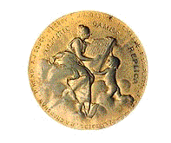 Paris 1900
Date opening: 14 May 1900
Date of closing: on October, 28 1900

Games of III Olympiad
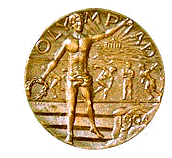 Saint Louis 1904
Date opening: 1 July 1904
Date of closing: on November, 23 1904

Games of IV Olympiad
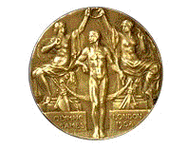
London 1908
Date opening: 27 April 1908
Date of closing: on October, 31 1908
Games of V Olympiad
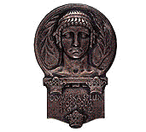 Stockholm 1912
Date opening: 5 May 1912
Date of closing: on July, 27 1912
Games of VII Olympiad
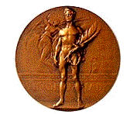
Antwerp 1920
Date opening: 20 April 1920
Date of closing: on September, 12 1920

Games of VIII Olympiad

 Paris 1924
Date opening: 4 May 1924
Date of closing: on July, 27 1924

Games of IX Olympiad
 Amsterdam 1928
Date opening: 17 May 1928
Date of closing: on August, 12 1928

Games of X Olympiad
 Los Angeles 1932
Date opening: 30 July 1932
Date of closing: on August, 14 1932
Games of XI Olympiad
 Berlin 1936
Date opening: 1 August 1936
Date of closing: on August, 16 1936
Games of XIV Olympiad
 London 1948
Date opening: 29 July 1948
Date of closing: on August, 14 1948

Games of XV Olympiad
 Helsinki 1952
Date opening: 19 July 1952
Date of closing: on August, 3 1952

Games of XVI Olympiad
 Melbourne 1956
Date opening: 22 November 1956
Date of closing: 8 December 1956

Games of XVII Olympiad
 Rome 1960
Date opening: 25 August 1960
Date of closing: on September, 11 1960

Games of XVIII Olympiad
 Tokyo 1964
Date opening: 10 October 1964
Date of closing: on October, 24 1964

Games of XIX Olympiad
 Mexico 1968
Date opening: 12 October 1968
Date of closing: on October, 27 1968

Games of XX Olympiad

 Munich 1972
Date opening: 26 August 1972
Date of closing: on September, 11 1972

Games of XXI Olympiad
 Montreal 1976
Date opening: 17 July 1976
Date of closing: on August, 1 1976

Games of XXII Olympiad
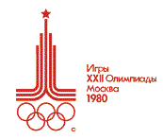 Moscow 1980
Date opening: 19 July 1980
Date of closing: on August, 3 1980

Games of XXIII Olympiad
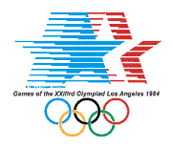 Los Angeles 1984
Date opening: 28 July 1984
Date of closing: on August, 12 19
Games of XXIV Olympiad
 Seoul 1988
Date opening: 17 September 1988
Date of closing: on October, 2 1988

Games of XXV Olympiad
Barcelona
1992 Date opening: 25 July 1992
Date of closing: on August, 9 1992

Games of XXVI Olympiad
 Atlanta 1996
Date opening: 19 July 1996
Date of closing: on August, 4 1996

Games of XXVII Olympiad
 Sydney 2000
Date opening: 15 September 2000
Date of closing: on October, 1 2000

Games of XXVIII Olympiad
Date of opening: on August, 13 2004
Date of closing: on August, 28 2004

